**2. Javascript Types**

Types in JS can get a little bit tricky.

There are 7 types of data in JS:

1. Integer.
2. Boolean.
3. String.
4. Undefined.
5. Null.
6. Symbol.
7. Object.

* Symbols are used for object properties so that the object properties are unique.
* **Undefined** is the absence of definition.
  + Function doesn’t return anything.
  + There is a variable there but nothing in it.
  + Missing property of an object.
* **Null** is absence of value.
* In JS 2 types of data type:
  + *Primitive data type*: Data only represents a single value.
    1. Integer.
    2. Boolean.
    3. String.
    4. Undefined.
    5. Null.
    6. Symbol.
  + *Non-primitive data type*: Doesn’t contain the actual value directly.
    1. Object.
    2. Array.
    3. Function.

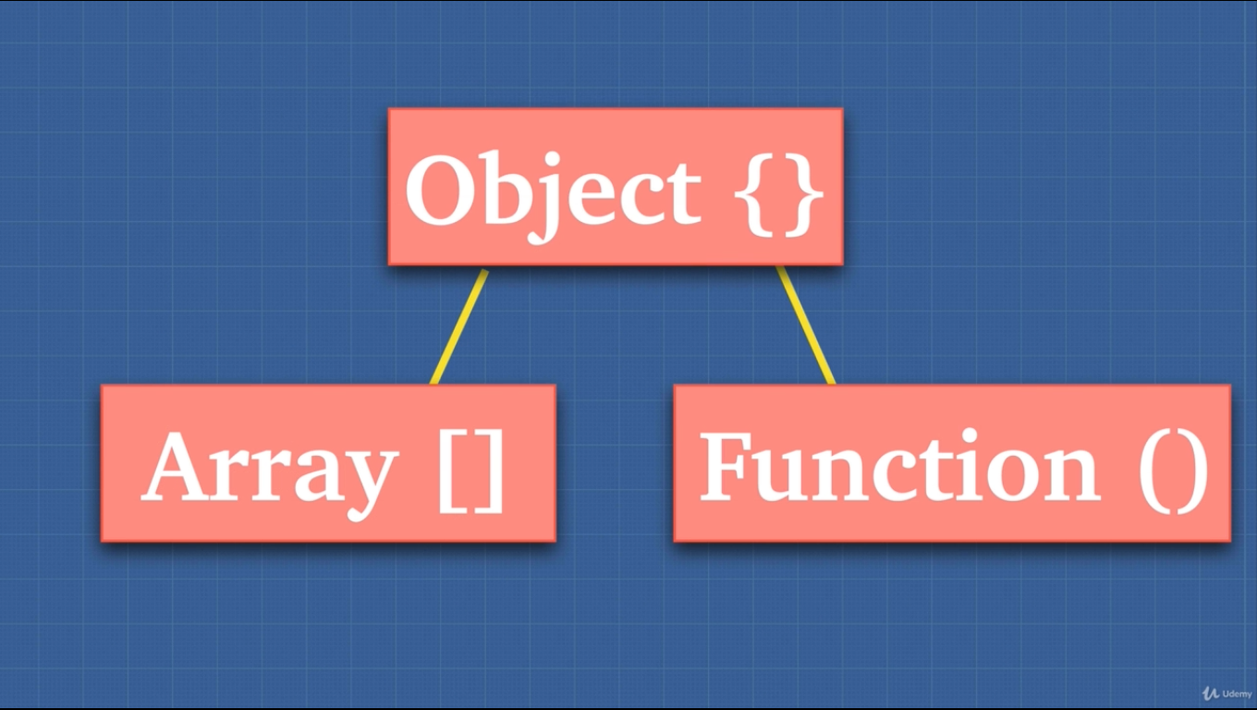

* Object doesn’t contain the actual value directly. It has a reference to its value somewhere to the memory.
* A common term that “Everything in JS is an object”. Well… not really.
  + There are a lot of built in objects that we can use.
  + Primitive types have object wrapper around them 😐.

**3. Array.isArray()**

* Underneath the hood **array** is an object in JS.
* Then how to check if something is an array. Using **.isArray()** method